TEAM 04 — APPLICATION
Step-by-Step Implementation & Verification Procedure
Zero Trust / SASE Capstone — Cloudflare
Team | Team 04 — Application
Students | Benduri Akshaya, Duvvapu Jahnav Anand Patel
Application / Public Hostname | dash.demotest.space
Internal Origin | http://localhost:8080

1. Objective
The objective is to place an authentication-protected front door in front of an internal web application. The application is made reachable through a public URL while the real internal server address is not exposed directly. Only identities allowed by the Cloudflare Access policy should reach the application.

2. Implementation Flow
- Verify that the internal web application is running.
- Open Cloudflare Zero Trust and create a Self-hosted application.
- Configure the application hostname and destination.
- Publish the application route through the Cloudflare Tunnel.
- Create an Access Policy that allows only the approved identity/domain.
- Use Policy Tester to verify allowed and blocked users.
- Open the public URL and verify the Cloudflare Access login and successful authenticated access.

3. Step-by-Step Procedure

Step 1 — Verify the Internal Web Application
Before publishing the application, confirm that the internal web application is running and can be opened locally.
- Open the application on the machine where the internal service is running.
- Verify that the application page loads successfully.
- In this implementation, the application is served from the local origin http://localhost:8080.
Expected result: The internal application page loads successfully before it is exposed through the Cloudflare-protected public URL.
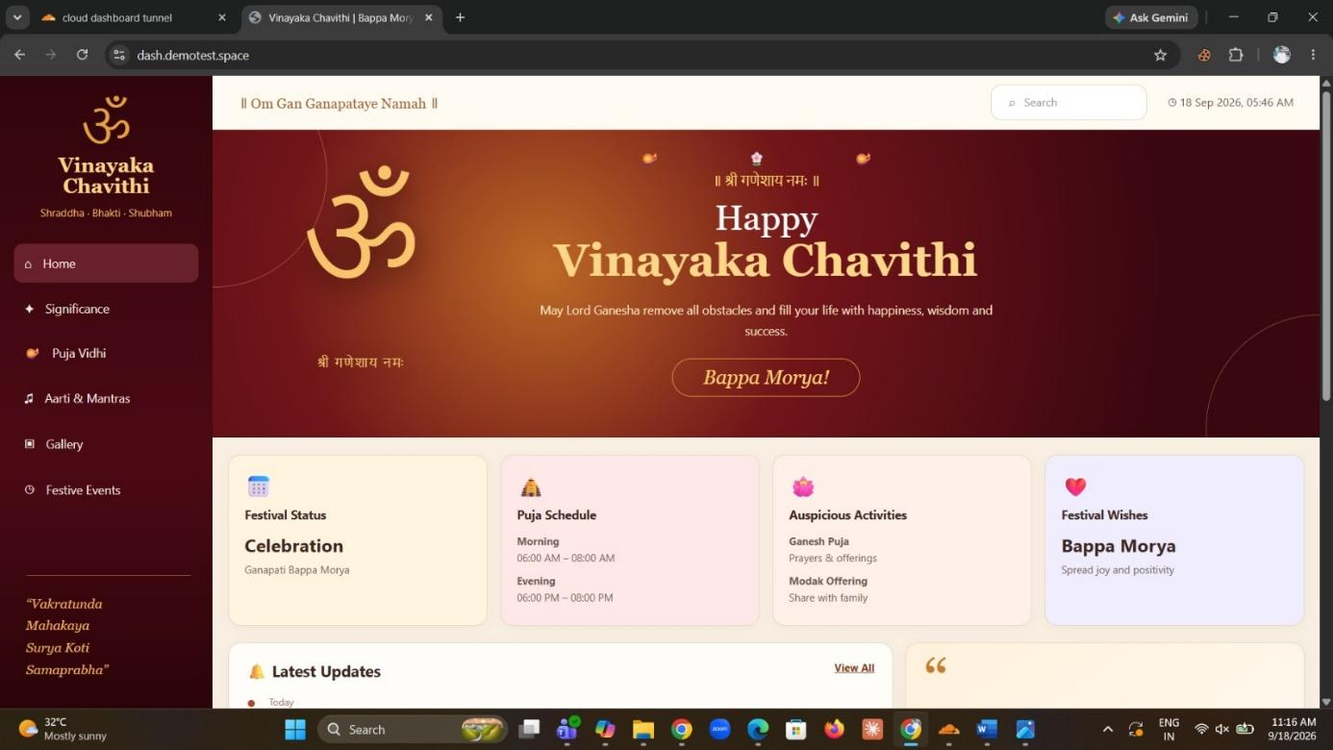
Figure 1. Internal web application running successfully.

Step 2 — Open Applications and Start a Self-hosted Application
- Sign in to the Cloudflare Zero Trust dashboard.
- Open Access controls → Applications.
- Click Add an application.
- Select Self-hosted.
Expected result: The Self-hosted application configuration screen opens.
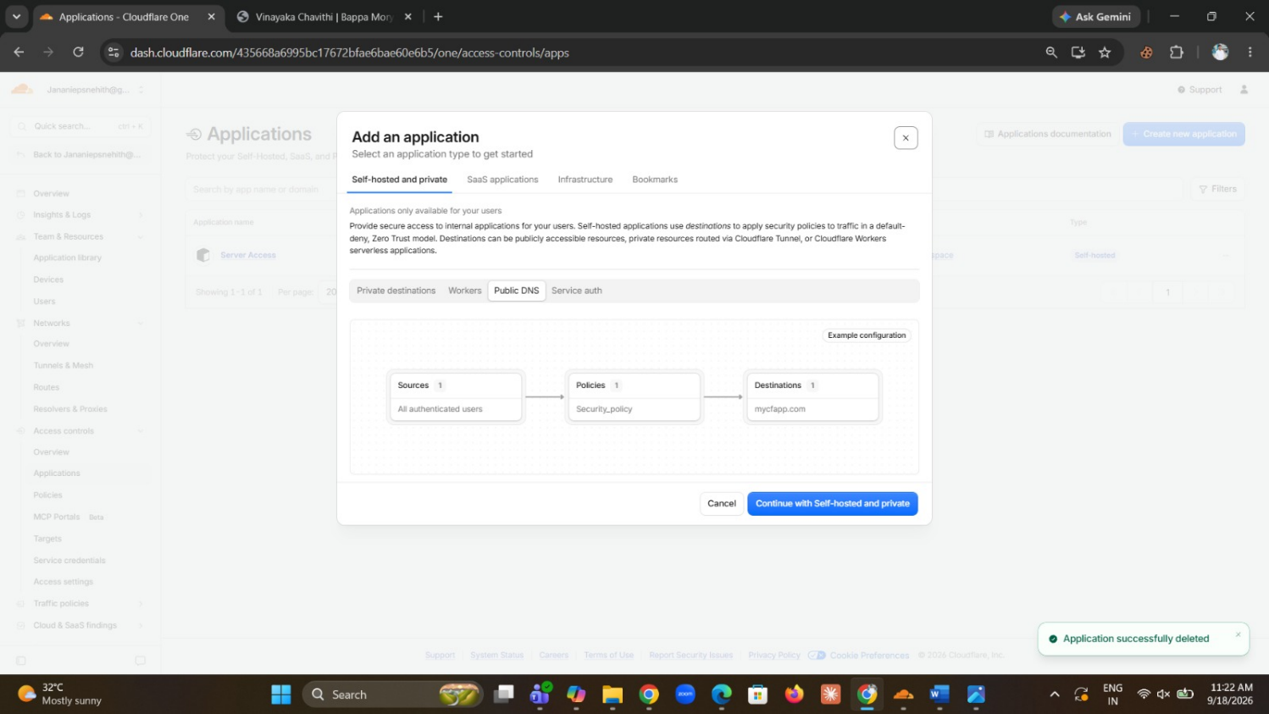
Figure 2. Access → Applications page showing the option to add an application.

Step 3 — Configure the Application
Configure the application so Cloudflare can identify the public destination and apply access control to it.
- Enter the application details in the Self-hosted application wizard.
- Configure the public hostname/subdomain used to access the application.
- Use the application hostname dash.demotest.space.
- Configure the destination/origin so the request is forwarded to the internal application.
- Continue through the wizard and save the application configuration.
Expected result: Cloudflare creates the self-hosted application and shows it in the Applications section.
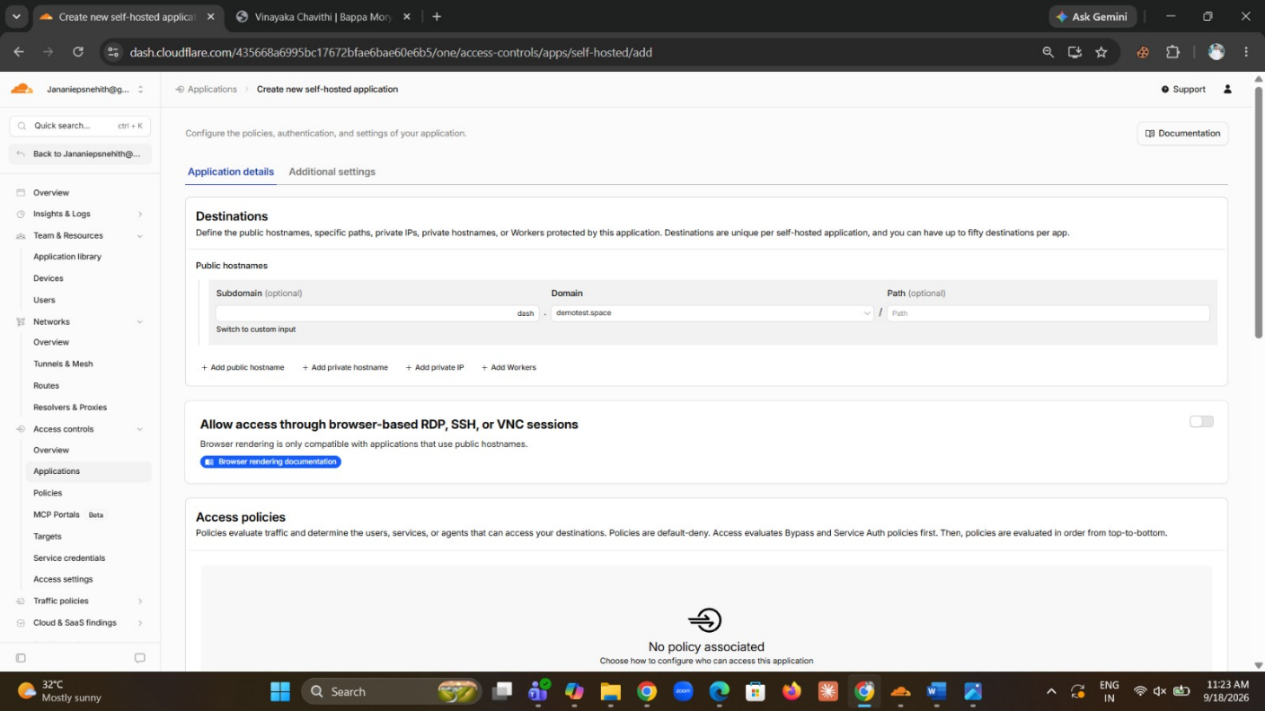
Figure 3. Self-hosted application configuration screen.
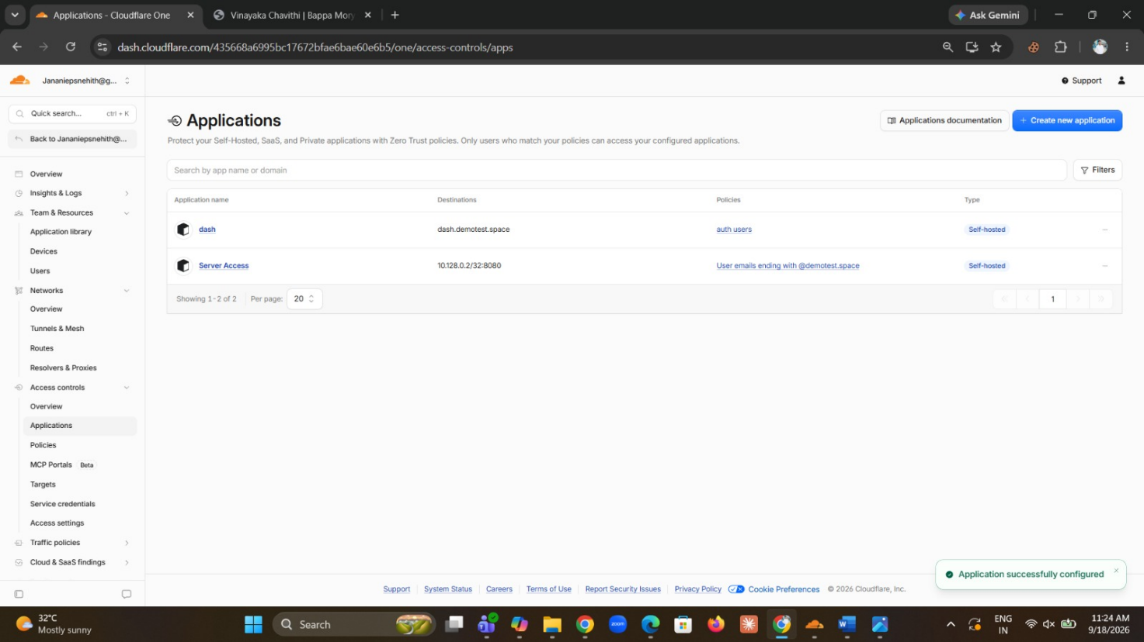
Figure 4. Application successfully configured and listed under the application library.

Step 4 — Publish the Application Route Through the Tunnel
The application need to be connected to the internal service, including the case where the service is behind Team 03's tunnel.
- Open Networks → Tunnels & Mesh / published application routes.
- Select the Cloudflare Dashboard Tunnel used for the application.
- Choose Add a published application route.
- Enter the public hostname dash.demotest.space.
- Leave the path empty when the complete hostname should match the application.
- Set the service/origin to the internal application address. In the completed setup, the route points to http://localhost:8080.
- Save the route.
Expected result: The published route appears in the tunnel configuration and connects the public hostname to the internal application.
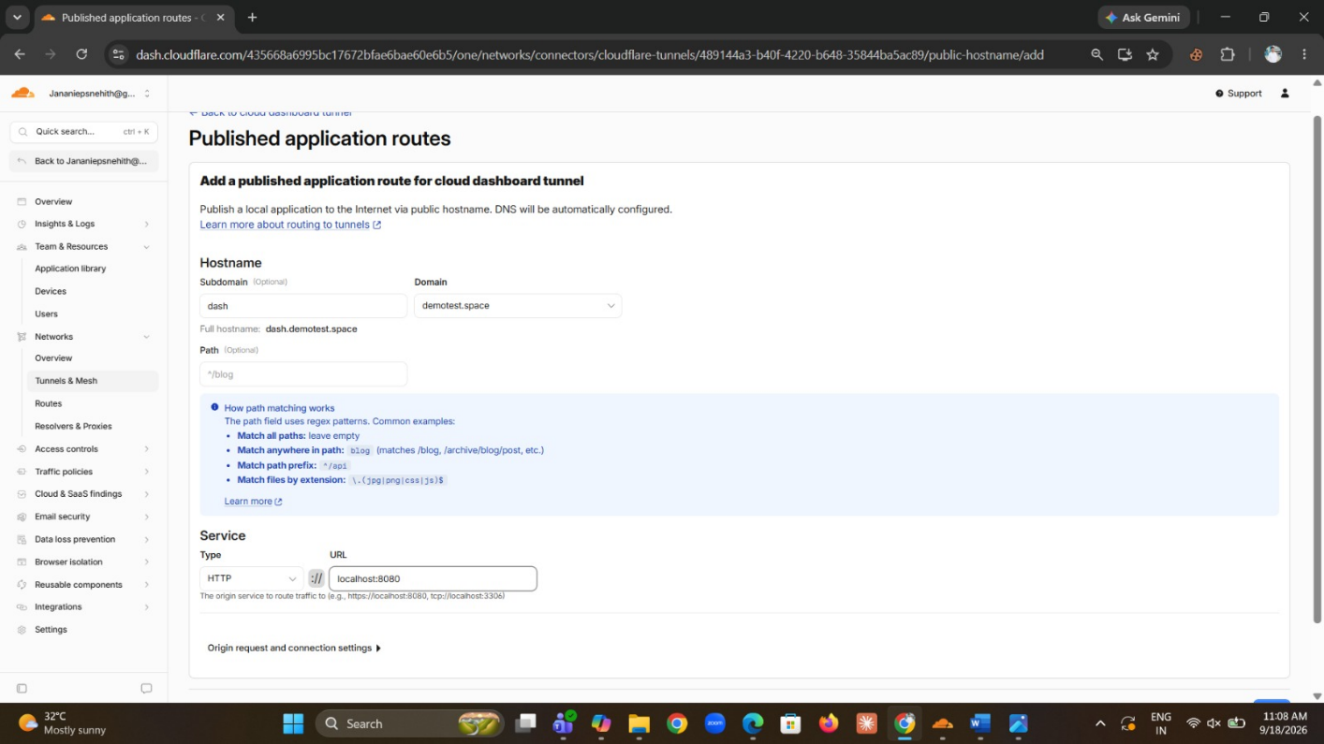
Figure 5. Published application route configuration screen.
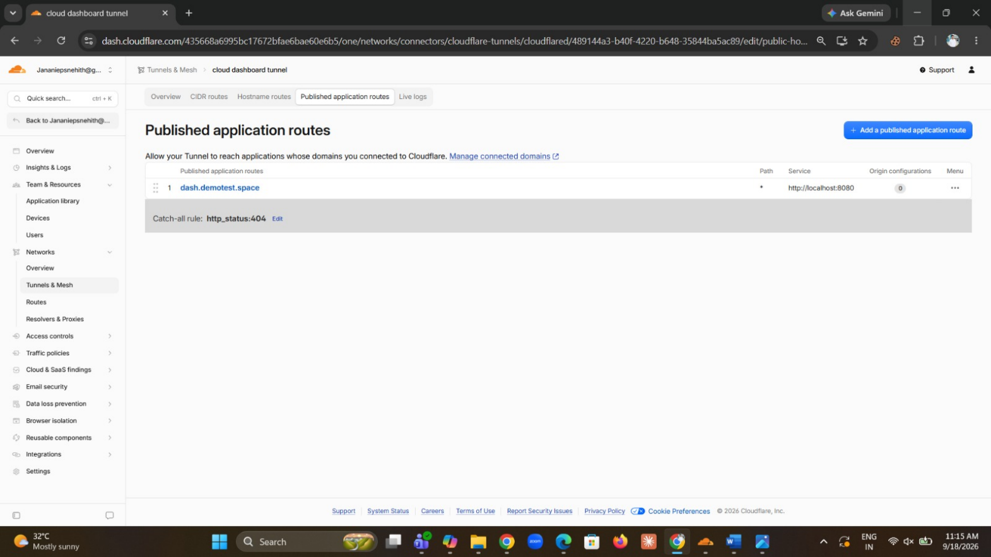
Figure 6. Published route showing dash.demotest.space mapped to http://localhost:8080.

Step 5 — Create the Cloudflare Access Policy
The application must not be openly accessible to everyone so create a policy and “Allow” policy restricted to the approved test identity group.
- Open Access controls → Policies.
- Create or edit the policy associated with the application.
- Set the Action to Allow.
- Under Include, select the required identity condition. In the completed setup, the condition is Emails ending in @demotest.space.
- Save the policy.
Expected result: Only users whose identity matches the configured allow condition can pass the access policy.
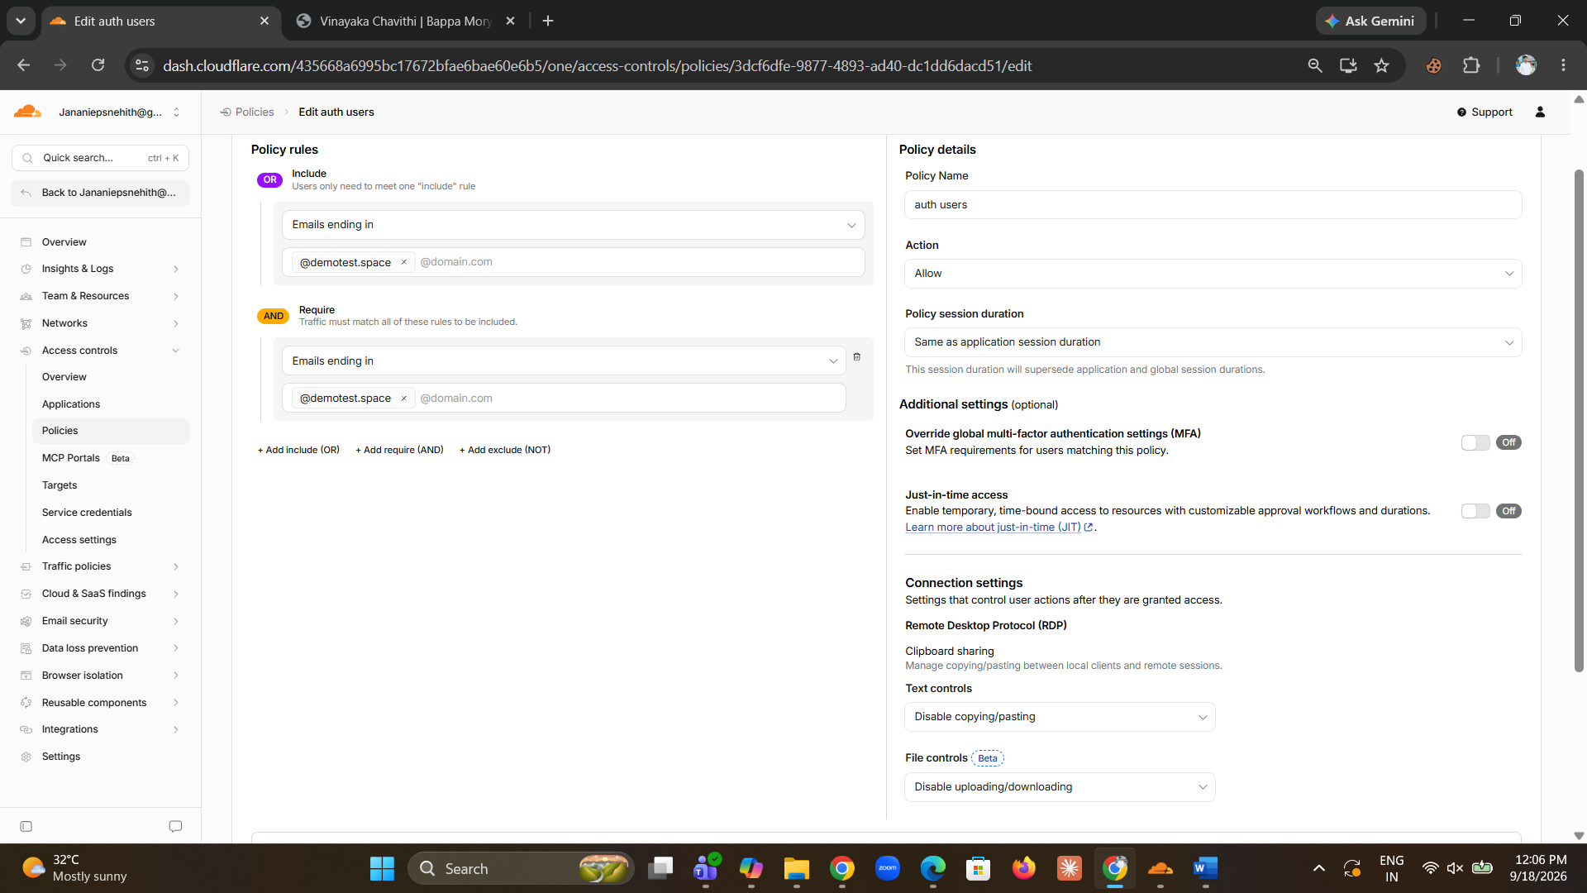
Figure 7. Access policy configured with an Allow action and an email-based Include rule.
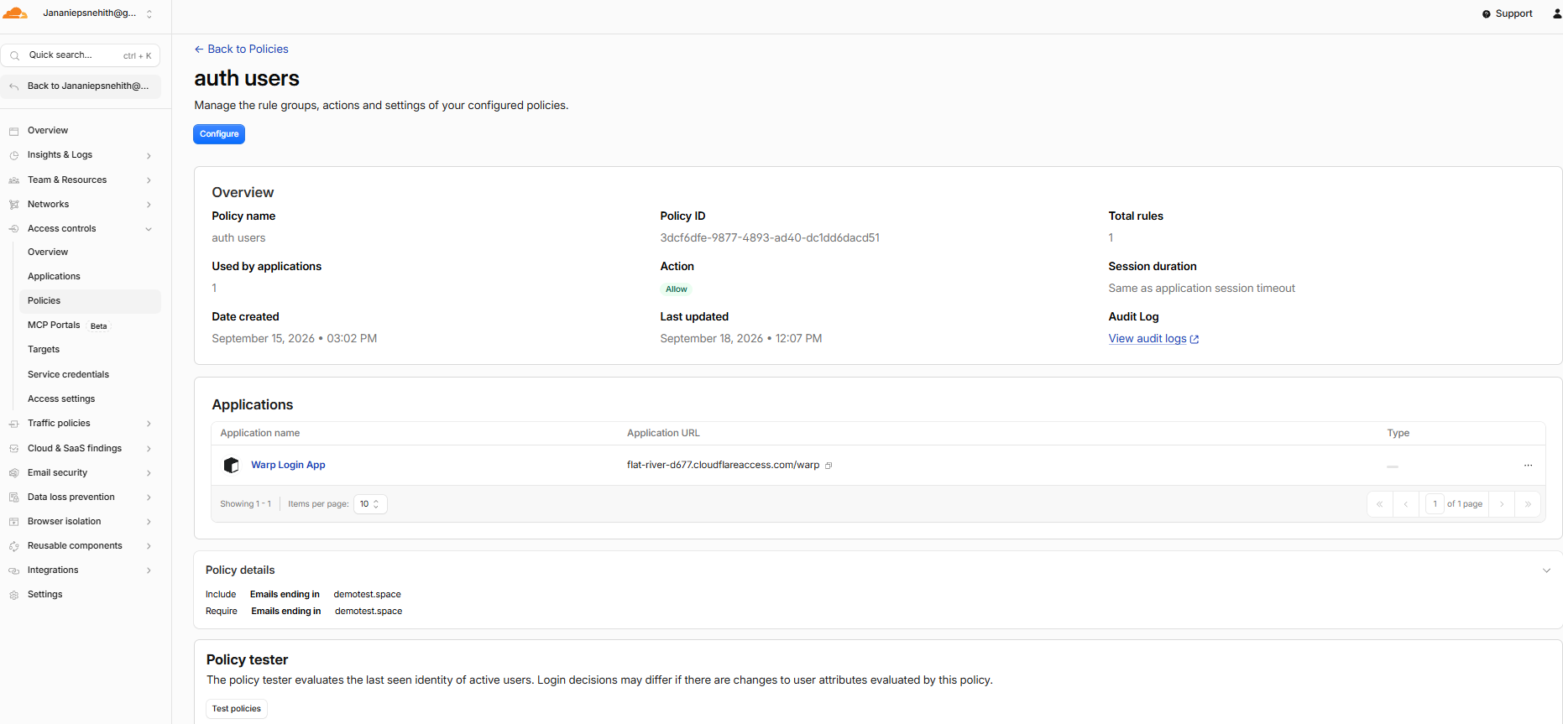
Figure 9. Saved policy details showing the configured identity rule and Allow action.
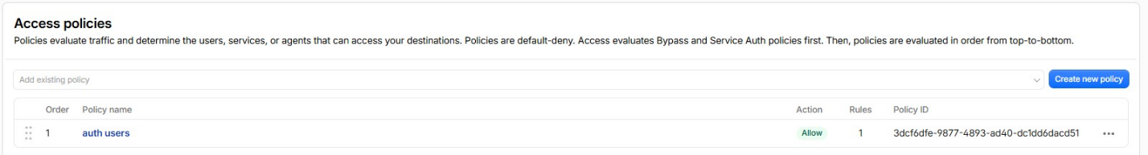
Figure 10. Access Policies list showing the active auth users policy.

Step 6 — Test the Access Policy
Use the built-in Policy Tester to confirm that the policy behaves differently for allowed and non-allowed identities.
- Open the auth users policy.
- Run the Policy Tester.
- Review the approved users section and the blocked users section.
- Confirm that users with the approved @demotest.space identity pattern are allowed.
- Confirm that users outside the approved identity pattern are blocked.
Expected result: The policy tester shows both allowed and blocked results, demonstrating that the access rule is being enforced.
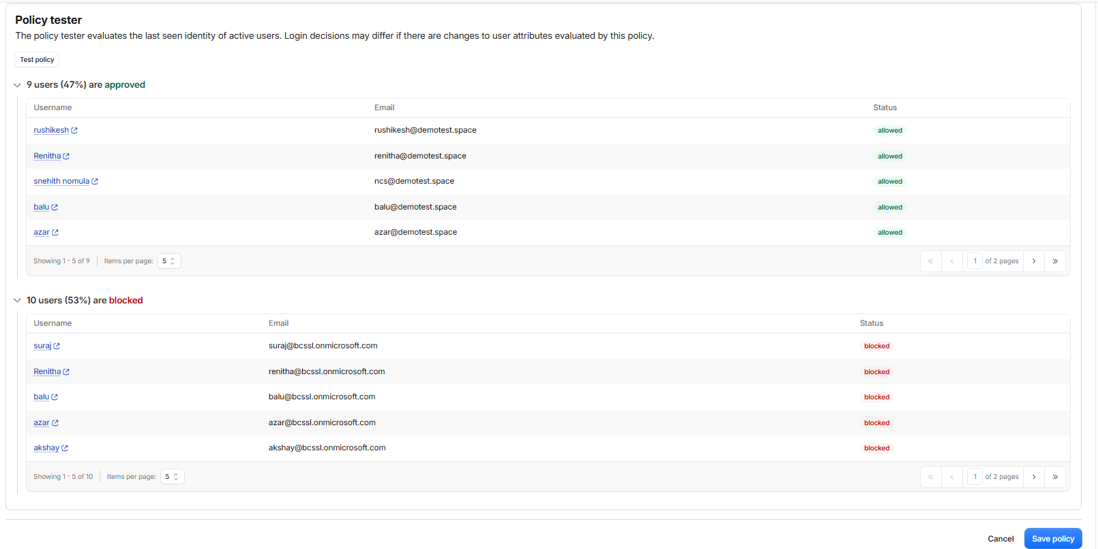
Figure 8. Policy Tester showing approved and blocked users.

Step 7 — Verify Authentication From the Public URL
Finally, test the application from the public hostname. The guide requires an unauthenticated user to see the Cloudflare Access login page before reaching the application.
- Open a normal browser window and visit the public URL for the application.
- Confirm that Cloudflare Access displays a login page instead of opening the application directly.
- Select the configured identity sign-in method.
- Sign in using an allowed account, such as the configured @demotest.space account.
- Complete the identity-provider sign-in steps.
- After successful authentication, verify that the actual internal web application opens.
Expected result: The user is authenticated first and is then allowed to reach the application. A user who does not satisfy the policy should not reach the application.
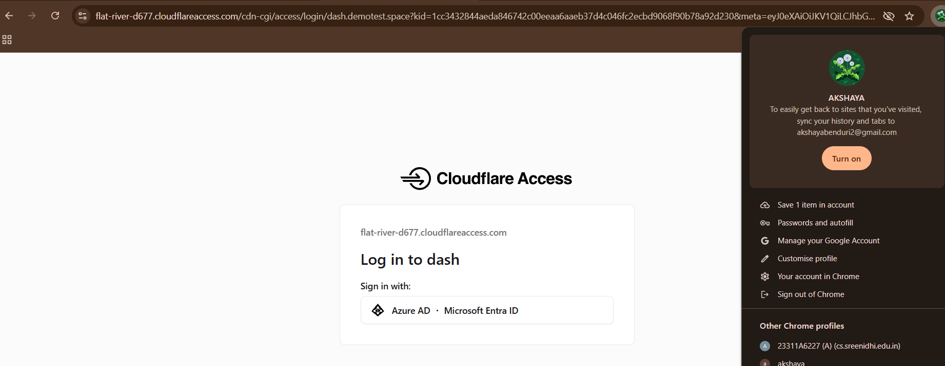
Figure 11. Cloudflare Access login page displayed before application access.
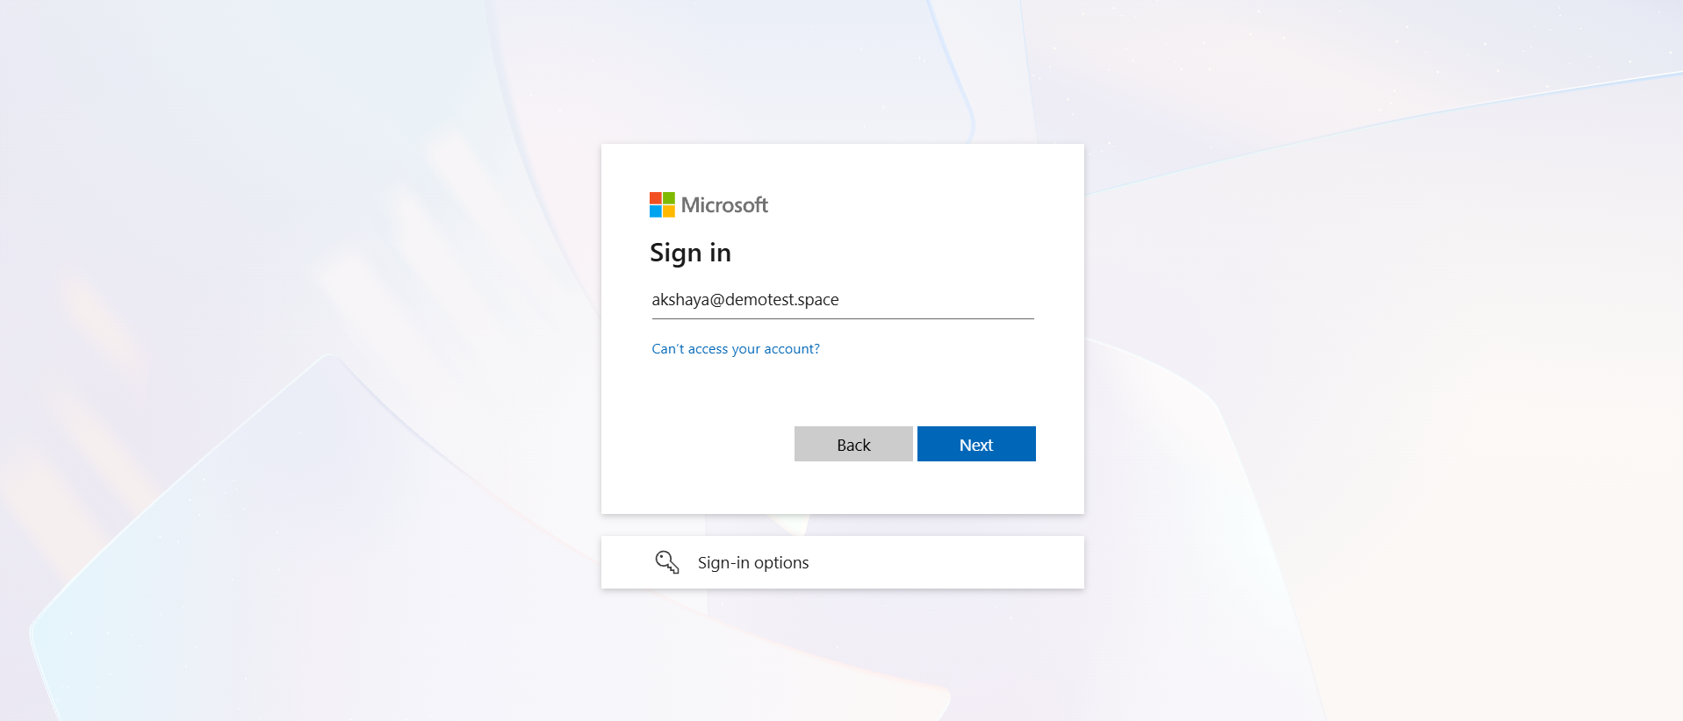
Figure 12. Identity-provider sign-in page.
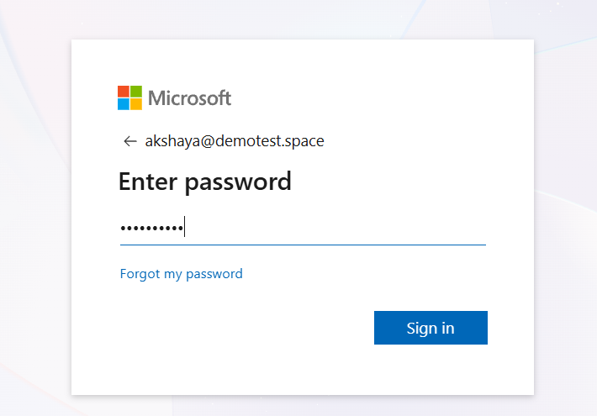
Figure 13. Password verification step.
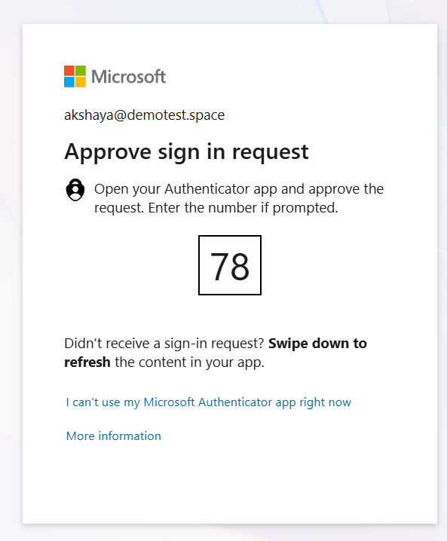
Figure 14. MFA approval step.
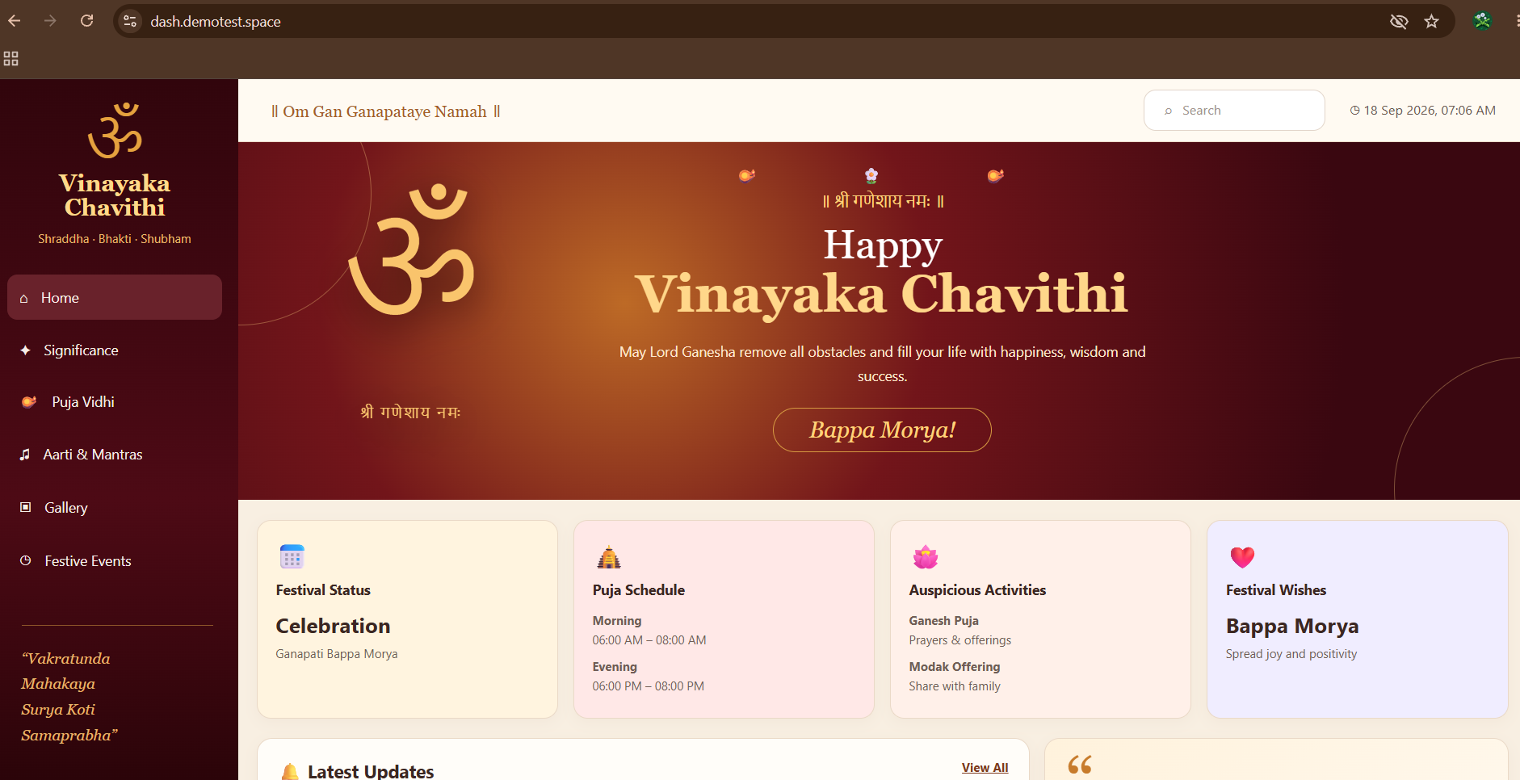
Figure 15. Application successfully opened after authentication.

4. Final Verification
- A public application URL is available for the internal application.
- Opening the public URL first displays the Cloudflare Access authentication page.
- Only identities matching the configured Access Policy can continue to the application.
- Policy Tester shows the expected allowed and blocked users.
- The internal service is reached through the configured tunnel/route rather than exposing its private address directly to the browser.
- Successful authentication, including MFA where configured, results in access to the actual application.

5. Result
Successfully configured a Self-hosted application protected by Cloudflare Access. The application is published through the public hostname dash.demotest.space, routed to the internal service, and protected by an identity-based Allow policy. Policy testing and end-to-end browser testing confirm that authentication is required before the application can be accessed.

